# Experiment No :1

**Aim :**

**CO1 :**

# Procedure:

# Output:

**Result:**

The program was executed and the result was successfully obtained. Thus CO1 was obtained.

# Experiment No: 2

**Aim :**

**CO1 :**

# Procedure:

# Output:

**Result:**

The program was executed and the result was successfully obtained. Thus CO1 was obtained.

# Experiment No :3

**Aim :**

**CO1 :**

# Procedure:

# Output:

**Result:**

The program was executed and the result was successfully obtained. Thus CO1 was obtained.

# Experiment No : 4

**Aim :**

**CO1 :**

# Procedure:

from sklearn.neighbors import KNeighborsClassifier

from sklearn.model_selection import train_test_split

from sklearn.datasets import load_iris

from sklearn.metrics import accuracy_score

iris=load_iris()

x=iris.data

y=iris.target

x_train,x_test,y_train,y_test=train_test_split(x,y,test_size=0.2,random_state=42)

knn=KNeighborsClassifier(n_neighbors=7)

knn.fit(x_train,y_train)

print(knn.predict(x_test))

v=knn.predict(x_test)

result=accuracy_score(y_test,v)

print("accuracy:",result)

# Output:

# 

**Result:**

The program was executed and the result was successfully obtained. Thus CO1 was obtained.

# Experiment No: 5

**Aim :**

**CO1 :**

# Procedure:

from sklearn.neighbors import KNeighborsClassifier

from sklearn.model_selection import train_test_split

from sklearn.datasets import load_digits

from sklearn.metrics import accuracy_score

digits=load_digits()

x=digits.data

y=digits.target

x_train,x_test,y_train,y_test=train_test_split(x,y,test_size=0.2,random_state=42)

k=KNeighborsClassifier(n_neighbors=10)

k.fit(x_train,y_train)

print(k.predict(x_test))

v=k.predict(x_test)

r=accuracy_score(y_test,v)

print("accuracy:",r)

# Output:

# 

**Result:**

The program was executed and the result was successfully obtained. Thus CO1 was obtained.

# Experiment No: 6

**Aim :**

**CO1 :**

# Procedure:

from sklearn.naive_bayes import GaussianNB

from sklearn.model_selection import train_test_split

from sklearn.datasets import load_iris

from sklearn.metrics import accuracy_score

iris=load_iris()

x=iris.data

y=iris.target

x_train,x_test,y_train,y_test=train_test_split(x,y,test_size=0.2,random_state=42)

clf=GaussianNB()

clf.fit(x_train,y_train)

print(clf.predict(x_test))

v=clf.predict(x_test)

result=accuracy_score(y_test,v)

print("accuracy:",result)

# Output:

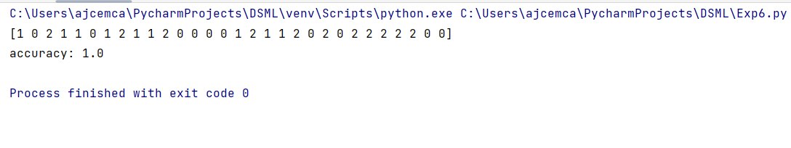

**Result:**

The program was executed and the result was successfully obtained. Thus CO1 was obtained.

# Experiment No: 7

**Aim :**

**CO1 :**

# Procedure:

from sklearn.naive_bayes import GaussianNB

from sklearn.model_selection import train_test_split

from sklearn.datasets import load_breast_cancer

from sklearn.metrics import accuracy_score,classification_report

bc=load_breast_cancer()

x=bc.data

y=bc.target

x_train,x_test,y_train,y_test=train_test_split(x,y,test_size=0.2,random_state=42)

clf=GaussianNB()

clf.fit(x_train,y_train)

print(clf.predict(x_test))

v=clf.predict(x_test)

result=accuracy_score(y_test,v)

report=classification_report(y_test,v)

print("accuracy:",result)

print("\nClassification:\n",report)

# Output:

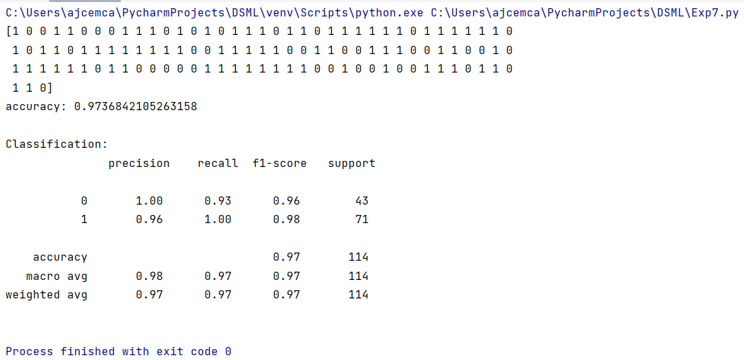

**Result:**

The program was executed and the result was successfully obtained. Thus CO1 was obtained.

# Experiment No: 8

**Aim :**

**CO1 :**

# Procedure:

from sklearn.tree import DecisionTreeClassifier

from sklearn.model_selection import train_test_split

from sklearn.datasets import load_iris

from sklearn.metrics import accuracy_score,classification_report

iris=load_iris()

x=iris.data

y=iris.target

x_train,x_test,y_train,y_test=train_test_split(x,y,test_size=0.2,random_state=42)

DT=DecisionTreeClassifier()

DT.fit(x_train,y_train)

print(DT.predict(x_test))

v=DT.predict(x_test)

result=accuracy_score(y_test,v)

report=classification_report(y_test,v)

print("accuracy:",result)

print("\nClassification:\n",report)

# Output:

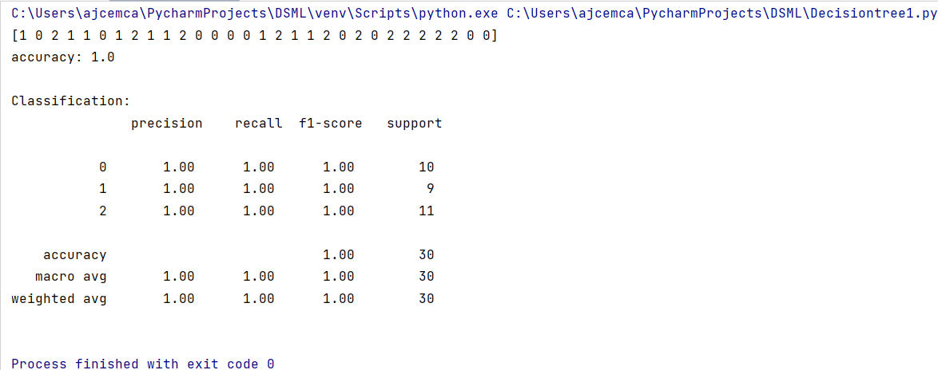

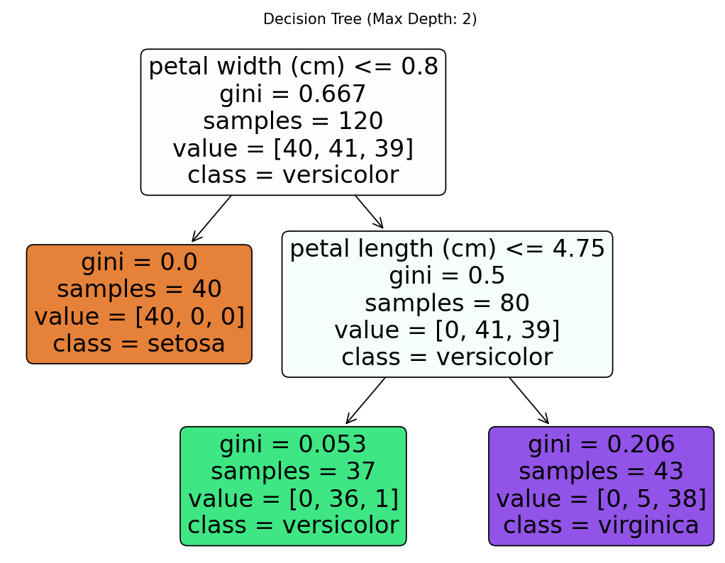

**Result:**

The program was executed and the result was successfully obtained. Thus CO1 was obtained.

# Experiment No: 9

**Aim :**

**CO1 :**

# Procedure:

from sklearn.tree import DecisionTreeClassifier

from sklearn.model_selection import train_test_split

from sklearn.datasets import load_breast_cancer

from sklearn.metrics import accuracy_score,classification_report

bc=load_breast_cancer()

x=bc.data

y=bc.target

x_train,x_test,y_train,y_test=train_test_split(x,y,test_size=0.2,random_state=42)

dt=DecisionTreeClassifier()

dt.fit(x_train,y_train)

print(dt.predict(x_test))

v=dt.predict(x_test)

result=accuracy_score(y_test,v)

report=classification_report(y_test,v)

print("accuracy:",result)

print("\nClassification:\n",report)

# Output:

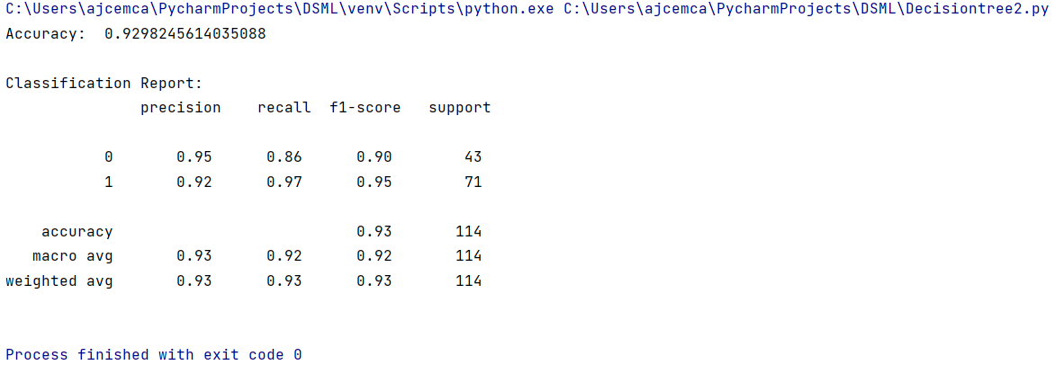

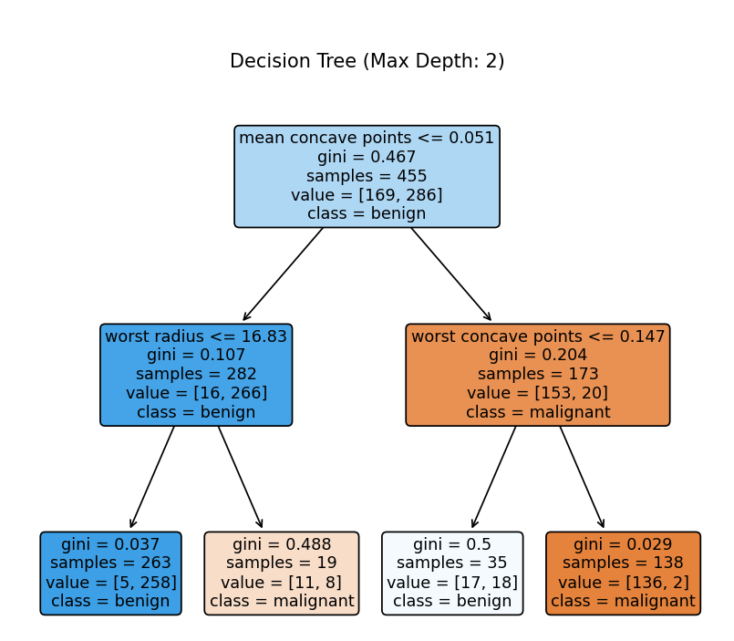

**Result:**

The program was executed and the result was successfully obtained. Thus CO1 was obtained.

# Experiment No: 10

**Aim :**

**CO1 :**

# Procedure:

# import pandas as pd

# from sklearn.datasets import fetch_california_housing

# from sklearn.linear_model import LinearRegression

# from sklearn.model_selection import train_test_split

# from sklearn.metrics import mean_squared_error

# ch=fetch_california_housing()

# df=pd.DataFrame(data=ch.data,columns=ch.feature_names)

# df['target']=ch.target

# x=df.drop('target',axis=1)

# y=df['target']

# x_train,x_test,y_train,y_test=train_test_split(x,y,test_size=0.2,random_state=42)

# lr=LinearRegression()

# lr.fit(x_train,y_train)

# v=lr.predict(x_test)

# result=mean_squared_error(y_test,v)

# print("Mean:",result)

# Output:

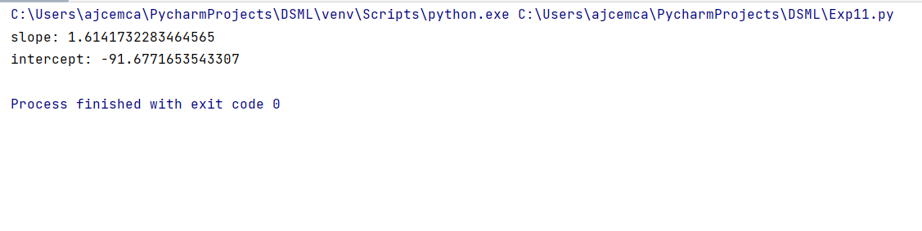

**Result:**

The program was executed and the result was successfully obtained. Thus CO1 was obtained.

# Experiment No: 11

**Aim :**

**CO1 :**

# Procedure:

import pandas as pd

import matplotlib.pyplot as plt

from sklearn.metrics import r2_score

from sklearn.model_selection import train_test_split

from sklearn.linear_model import LinearRegression

data = pd.read_csv('Salary_Data.csv')

x = data['YearsExperience'].values.reshape(-1, 1)

y = data['Salary'].values

x_train, x_test, y_train, y_test = train_test_split(x, y, test_size=0.2, random_state=42)

slr = LinearRegression()

slr.fit(x_train, y_train)

y_pred = slr.predict(x_test)

r2 = r2_score(y_test, y_pred)

print("R-squared :", r2)

plt.scatter(x_test,y_test,color='black',label ='Data Points')

plt.plot(x_test,y_pred,color='blue',linewidth=3 ,label='Regression line')

plt.xlabel('Years of Experience')

plt.ylabel('Salary')

plt.legend()

plt.show()

# Output:

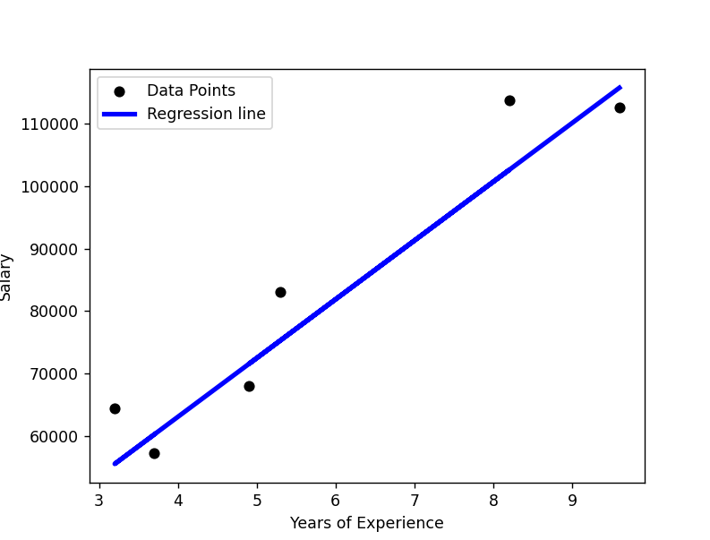

**Result:**

The program was executed and the result was successfully obtained. Thus CO1 was obtained.

# Experiment No: 12

**Aim :**

**CO1 :**

# Procedure:

import pandas as pd

from sklearn.datasets import fetch_california_housing

from sklearn.linear_model import LinearRegression

from sklearn.model_selection import train_test_split

from sklearn.metrics import mean_squared_error

ch=fetch_california_housing()

df=pd.DataFrame(data=ch.data,columns=ch.feature_names)

df['target']=ch.target

x=df.drop('target',axis=1)

y=df['target']

x_train,x_test,y_train,y_test=train_test_split(x,y,test_size=0.2,random_state=42)

lr=LinearRegression()

lr.fit(x_train,y_train)

v=lr.predict(x_test)

result=mean_squared_error(y_test,v)

print("Mean:",result)

# Output:

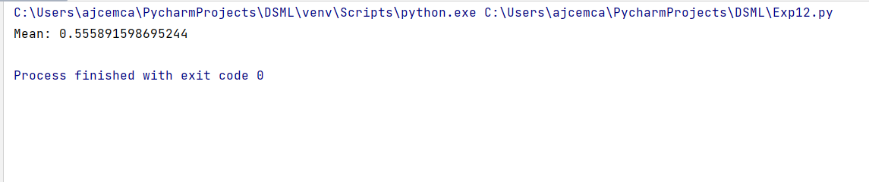

**Result:**

The program was executed and the result was successfully obtained. Thus CO1 was obtained.

# Experiment No: 13

**Aim :**

**CO1 :**

Use different packages and frameworks to implement text classification using SVM and clustering using k-means

# Procedure:

from sklearn.datasets import load_iris

from sklearn.cluster import KMeans

import matplotlib.pyplot as plt

iris = load_iris()

x = iris.data

y = iris.target

kmeans = KMeans(n_clusters=3, random_state=42)

kmeans.fit(x)

cluster_labels = kmeans.labels_

print(cluster_labels)

centroids = kmeans.cluster_centers_

print(centroids)

plt.scatter(x[:, 0], x[:, 1], c=cluster_labels, cmap='viridis', marker='o', edgecolor='black')

plt.scatter(centroids[:, 0], centroids[:, 1], marker='*', s=200, c='red', label='centroid')

plt.xlabel(iris.feature_names[0])

plt.ylabel(iris.feature_names[1])

plt.title("Kmeans clustering of Dataset Iris")

plt.legend()

plt.show()

# 

# 

# 

# 

# 

# 

# Output:

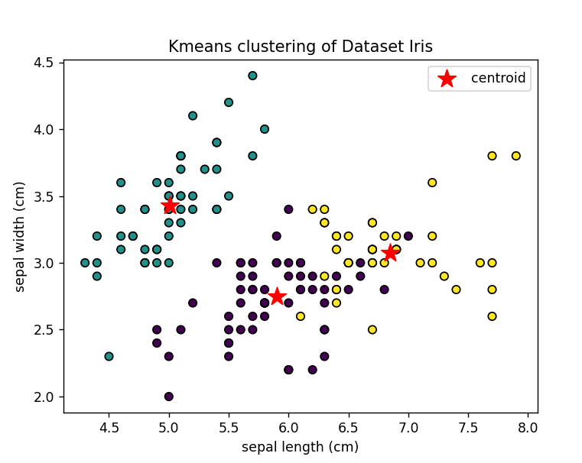

**Result:**

The program was executed and the result was successfully obtained. Thus CO1 was obtained.

# Experiment No: 14

**Aim :**

**CO1 :**

Use different packages and frameworks to implement text classification using SVM and clustering using k-means

# Procedure:

# from sklearn.datasets import load_breast_cancer

# from sklearn.cluster import KMeans

# import matplotlib.pyplot as plt

# bc = load_breast_cancer()

# x = bc.data

# y = bc.target

# kmeans = KMeans(n_clusters=3, random_state=42)

# kmeans.fit(x)

# cluster_labels = kmeans.labels_

# print(cluster_labels)

# centroids = kmeans.cluster_centers_

# print(centroids)

# plt.scatter(x[:, 0], x[:, 1], c=cluster_labels, cmap='viridis', marker='o', edgecolor='black')

# plt.scatter(centroids[:, 0], centroids[:, 1], marker='*', s=200, c='red', label='centroid')

# plt.xlabel(bc.feature_names[0])

# plt.ylabel(bc.feature_names[1])

# plt.title("Kmeans clustering of breast cancer Dataset ")

# plt.legend()

# plt.show()

# 

# 

# 

# Output:

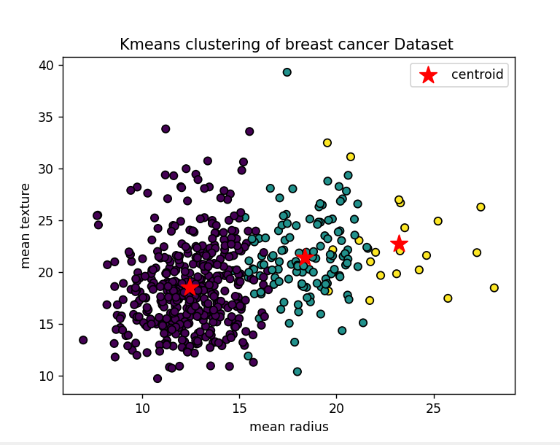

**Result:**

The program was executed and the result was successfully obtained. Thus CO1 was obtained.

# Experiment No :15

**Aim :** Program to implement text classification using support vector machine

**CO3 :**

# Procedure:

from sklearn.datasets import fetch_20newsgroups

from sklearn.feature_extraction.text import TfidfVectorizer

from sklearn.model_selection import train_test_split

from sklearn.svm import SVC

from sklearn.metrics import classification_report,accuracy_score

categories=['alt.atheism','soc.religion.christian','comp.graphics','sci.med']

twenty_train=fetch_20newsgroups(subset="train",categories=categories,shuffle=True,random_state=42)

vectorizer=TfidfVectorizer()

x_train_tfidf=vectorizer.fit_transform(twenty_train.data)

y_train=twenty_train.target

x_train,x_test,y_train,y_test=train_test_split(x_train_tfidf,y_train,test_size=0.3,random_state=42)

svm_classifier=SVC(kernel='linear',random_state=42)

svm_classifier.fit(x_train,y_train)

pred=svm_classifier.predict(x_test)

accuracy_score=accuracy_score(y_test,pred)

class_report=classification_report(y_test,pred,target_names=twenty_train.target_names)

print("Accuracy Score",accuracy_score)

print("Classification Report\n",class_report)

new_data = [

"Computer graphics"

]

x_new_tfidf=vectorizer.transform(new_data)

new_pred=svm_classifier.predict(x_new_tfidf)

for i,text in enumerate(new_data):

predicted_category=twenty_train.target_names[new_pred[i]]

print("Predicted Category:",predicted_category)

# Output:

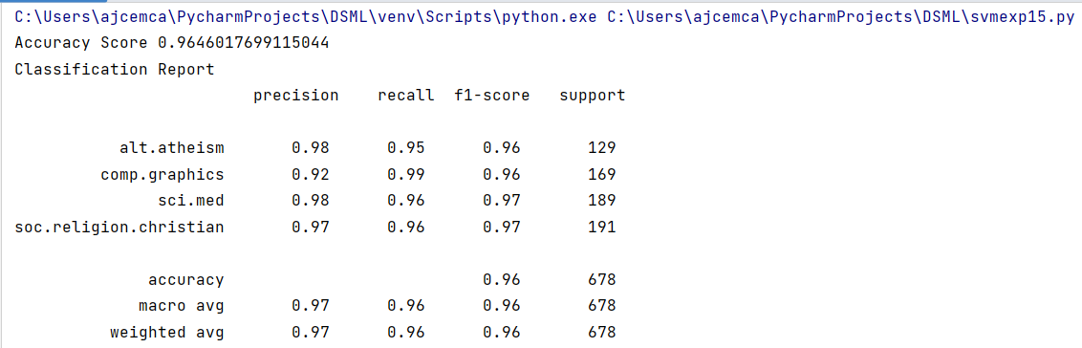

**Result:**

The program was executed and the result was successfully obtained. Thus CO1 was obtained.